**Cambodia Economic Analytics and Research**

EDA and Unsupervised Learning Course

Group I4-AMS-B

Team 07

KRY Senghort, NOR Phanit, PHUONG Bunthoeun

Professor: Dr. Phauk Sokkhey Course

Dr. HAS Sothea TP

Due date: 08-November-2025

**Contents:**

1. Project Background
2. Project Objectives
3. Research Problems
4. Scope Statement
5. Stakeholder Analysis
   1. Key Stakeholder
   2. Roles and Responsibilities
6. Project Constraints & Assumptions
   1. Constraints
   2. Assumptions
7. Initial Risk Assessment
8. Project Timeline
9. Conclusion
10. **Project Background:**

This Cambodia’s Economic Analytic and Research project is designed to provide an in-depth analysis of economic data to uncover trends, patterns, and insights that can drive strategic decision-making and policy development. By leveraging powerful tools and technologies like Python, Power BI, and R, the project aims to apply sophisticated data science methods to transform raw data into meaningful insights for economic development.

Python will serve as the primary tool for data processing, analysis, and machine learning model implementation, allowing for efficient handling and analysis of large datasets. R will complement Python by providing robust statistical analysis capabilities, which are essential for understanding the underlying economic indicators and validating results. Power BI will then be used to create interactive dashboards, transforming complex analytical findings into easy-to-understand visuals for policymakers, stakeholders, and other users, thus facilitating data-driven decision-making.

The project will utilize a structured data workflow, beginning with data preprocessing and transformation, which will ensure data quality, consistency, and usability. Advanced statistical methods will be applied to conduct exploratory data analysis, enabling the identification of correlations, patterns, and trends that are significant for Cambodia’s economic landscape. Machine learning models will further enhance the project’s analytical power, enabling predictive analysis and forecasting that can provide insights into future economic conditions.

Key applications of this project include monitoring economic growth, assessing the impact of policy changes, and identifying factors that influence economic stability. The project’s outcome will address critical economic challenges, support sustainable development, and contribute valuable insights for improving Cambodia's socio-economic resilience. Through this comprehensive data analysis initiative, the project ultimately aims to empower decision-makers with actionable insights that can support the country's economic progress and sustainable development goals.

1. **Project Objectives:**

The objectives of the *Cambodia’s Economic Analytic and Research* project are focused on producing detailed, data-driven insights that guide Cambodia’s economic planning and policy formulation. Starting with rigorous data preparation, the project aims to ensure high-quality, standardized data for analysis, setting the foundation for accurate and reliable results. Through exploratory data analysis, it will reveal essential patterns and relationships within the economic data, highlighting factors such as income distribution, employment rates, and regional economic disparities that are critical for informed policy decisions.

The project will utilize machine learning models to forecast trends in areas like GDP growth and sector performance, equipping policymakers with predictive insights that help anticipate future economic conditions. By building interactive dashboards in Power BI, the project seeks to provide stakeholders with clear, customizable visualizations that translate complex data into accessible, real-time information. Additionally, the analysis will assess the impact of existing policies and offer targeted recommendations, identifying where economic intervention could drive sustainable growth. Aligned with Cambodia’s sustainable development goals, the project aims to foster data-driven, proactive decision-making that supports long-term economic stability and progress across regions and sectors, enhancing the country’s socio-economic resilience.

1. **Research Problems:**

Here are some research problem questions for the *Cambodia’s Economic Analytic and Research* project:

* + Taxation Analysis**:** How does the current taxation structure affect income distribution and economic growth in Cambodia? What is the impact of different tax types (e.g., income, corporate, VAT) on business growth and individual purchasing power?
  + Import and Export Analysis: How do trade imbalances impact employment and GDP growth across different sectors in Cambodia? What are the primary challenges and opportunities in Cambodia’s export and import sectors that affect economic resilience?
  + Exchange Rate Analysis: What is the relationship between exchange rate fluctuations and inflation in Cambodia? How do changes in the exchange rate impact Cambodia’s trade balance and cost of imported goods?
  + Unemployment and Employment Analysis: How do sectoral employment patterns correlate with GDP growth, and what policies could enhance employment in high-impact sectors? What are the causes of regional disparities in employment, and how do they affect economic growth in Cambodia?
  + GDP Analysis:What are the primary drivers of GDP growth in Cambodia, and how do these vary across regions? How can GDP growth trends help forecast economic stability and guide resource allocation to reduce regional inequalities?
  + Inflation Rate Analysis: How does inflation affect poverty levels and the economic well-being of different income groups in Cambodia? What are the underlying causes of inflation, and how do they impact essential commodity prices and consumer purchasing power?
  + Integrated Economic Policy Evaluation Analysis: How effective are Cambodia’s economic policies in promoting sustainable growth and resilience against global economic fluctuations? What policy interventions could help strengthen Cambodia's economic resilience to mitigate the effects of inflation, unemployment, and trade imbalances?

These questions are structured to encourage data-driven investigation into core economic issues, with the potential to inform policy recommendations and strategic planning for Cambodia's economic development.

1. **Scope Statement**

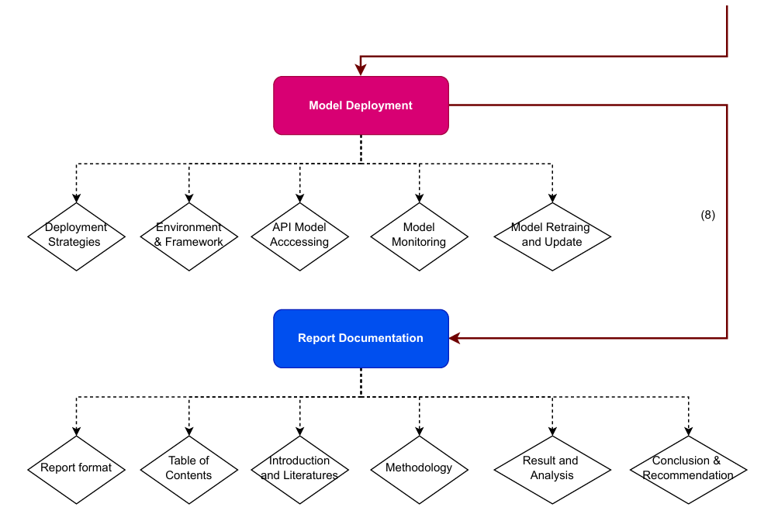

1. **Stakeholder Analysis**
   * 1. **Key Stakeholder**
        + Project Sponsor: Provides financial support and strategic direction; high influence on project success.
        + Project Manager: Oversees project execution, ensures tasks are completed on time; central to day-to-day operations.
        + Team Members: Execute tasks and activities; their involvement impacts project delivery.
        + Customers/End Users: Use or benefit from the project’s outcome; their feedback is crucial for product quality.
        + Investors/Shareholders: Provide funding and expect returns; have high interest in financial success.
        + Regulatory Authorities: Ensure compliance with laws and regulations; influence project through legal oversight.
        + Suppliers/Contractors: Provide goods and services; affect project through timely and quality delivery.
        + Internal Departments: Contribute across various project aspects; key for coordination and resource allocation.
        + Local Community: Affected by project’s impact on the environment, economy, or society; influence through public perception.
        + Advisory Board/Steering Committee: Provide strategic guidance; high influence in decision-making.
        + Media: Shape public perception and reputation; moderate influence on public support.

Each stakeholder group has a different level of influence and interest, which determines how and how often they need to be engaged.

* + 1. **Roles and Responsibilities**
       - Project Sponsor
         * Role: Provides financial backing and strategic direction.
         * Responsibilities: Approve budgets, ensure alignment with goals, remove barriers.
       - Project Manager
         * Role: Manages project execution.
         * Responsibilities: Plan, organize, manage resources, monitor progress.
       - Team Members
         * Role: Execute project tasks.
         * Responsibilities: Complete tasks on time, collaborate, provide updates.
       - Customers/End Users
         * Role: Use or benefit from the project’s outcome.
         * Responsibilities: Provide feedback, participate in testing, use the product.
       - Investors/Shareholders
         * Role: Provide funding.
         * Responsibilities: Monitor financial health, ensure returns on investment.
       - Regulatory Authorities
         * Role: Ensure compliance with laws and regulations.
         * Responsibilities: Monitor compliance, issue approvals.
       - Suppliers/Contractors
         * Role: Provide resources (goods/services).
         * Responsibilities: Deliver on time and quality, manage contracts.
       - Internal Departments (e.g., Marketing, IT, HR)
         * Role: Support with expertise.
         * Responsibilities: Provide resources and knowledge.
       - Local Community
         * Role: Affected by the project’s outcomes.
         * Responsibilities: Support, raise concerns, ensure social/environmental responsibility.
       - Advisory Board/Steering Committee
         * Role: Provide strategic oversight.
         * Responsibilities: Guide with expertise, make high-level decisions.
       - Media
         * Role: Influence public perception.
         * Responsibilities: Report on milestones, shape public narrative.

1. **Project Constraints & Assumptions**
   1. **Constraints**
      * + Time: Limited project duration or deadlines for deliverables.
        + Budget: Financial limitations for resources, staffing, and materials.
        + Scope: The boundaries of what the project will and won’t deliver.
        + Quality: Expectations for the quality of deliverables may affect time and budget.
        + Resources: Availability of skilled personnel, equipment, and technology.
        + Regulations: Compliance with legal, environmental, or industry standards.
        + Stakeholder Expectations: Meeting diverse expectations and managing conflicts.
   2. **Assumptions**
      * + Availability of Resources: Necessary personnel, equipment, and technology will be available as planned.
        + Stakeholder Engagement: Key stakeholders will provide timely feedback and support.
        + Technology Stability: The technology being used will function as expected without major issues.
        + Team Capability: The project team has the necessary skills and experience.
        + External Factors: No significant external events (e.g., economic, political) will disrupt the project.
        + Market Conditions: Market conditions will remain stable for the duration of the project.
        + Data Availability: Necessary data or inputs will be accessible and accurate.

These constraints and assumptions must be regularly reviewed and managed to ensure project success.

1. **Initial Risk Assessment**
   * + - Time Delays: Risk of missing deadlines due to unexpected challenges or delays in task execution.
       - Budget Overruns: Risk of exceeding the allocated budget due to unforeseen costs or poor financial management.
       - Resource Shortages: Risk of not having enough skilled personnel, equipment, or technology to complete the project.
       - Scope Creep: Risk of unplanned changes or additions to the project scope, affecting time and budget.
       - Stakeholder Misalignment: Risk of miscommunication or conflicting expectations among stakeholders.
       - Regulatory Compliance: Risk of failing to meet legal, industry, or environmental regulations, leading to fines or delays.
       - Technology Failures: Risk of technological issues, such as software bugs, hardware malfunctions, or system incompatibility.
       - Quality Issues: Risk of delivering subpar quality or not meeting project standards and expectations.
       - External Disruptions: Risk from external factors such as economic downturns, political instability, or natural disasters.
       - Data Inaccuracy: Risk of inaccurate or incomplete data affecting project decisions or outcomes.

Identifying these risks early allows for mitigation strategies to be put in place, increasing the likelihood of project success.

1. **Project Timeline:**

|  |  |  |  |  |  |  |  |  |  |  |  |  |  |  |  |  |
| --- | --- | --- | --- | --- | --- | --- | --- | --- | --- | --- | --- | --- | --- | --- | --- | --- |
| Descriptions | W(1-2) | | W(3-4) | | W(5-6) | | W(7-8) | | W(9-10) | | W(11-12) | | W(13-14) | | W(15-16) | |
| I.) Define Topic, Objectives & Research Problems |  |  |  |  |  |  |  |  |  |  |  |  |  |  |  |  |
| 1.1. Topic Research |  |  |  |  |  |  |  |  |  |  |  |  |  |  |  |  |
| 1.2. Objectives |  |  |  |  |  |  |  |  |  |  |  |  |  |  |  |  |
| 1.3. Research Problems |  |  |  |  |  |  |  |  |  |  |  |  |  |  |  |  |
| II.) Study relevant literature reviews |  |  |  |  |  |  |  |  |  |  |  |  |  |  |  |  |
| 2.1. Khmer literature reviews |  |  |  |  |  |  |  |  |  |  |  |  |  |  |  |  |
| 2.1. English literature reviews |  |  |  |  |  |  |  |  |  |  |  |  |  |  |  |  |
| II.) Data Collection |  |  |  |  |  |  |  |  |  |  |  |  |  |  |  |  |
| 2.1. Data Sources |  |  |  |  |  |  |  |  |  |  |  |  |  |  |  |  |
| 2.2. Web scrapping |  |  |  |  |  |  |  |  |  |  |  |  |  |  |  |  |
| 2.3. Document scrapping |  |  |  |  |  |  |  |  |  |  |  |  |  |  |  |  |
| III.) Data Cleaning |  |  |  |  |  |  |  |  |  |  |  |  |  |  |  |  |
| 3.1. Handle missing value |  |  |  |  |  |  |  |  |  |  |  |  |  |  |  |  |
| 3.2. Detect duplicate value |  |  |  |  |  |  |  |  |  |  |  |  |  |  |  |  |
| 3.3. Standardize data format |  |  |  |  |  |  |  |  |  |  |  |  |  |  |  |  |
| IV.) Data Transformation |  |  |  |  |  |  |  |  |  |  |  |  |  |  |  |  |
| 4.1. Feature scaling |  |  |  |  |  |  |  |  |  |  |  |  |  |  |  |  |
| 4.2. Feature normalization |  |  |  |  |  |  |  |  |  |  |  |  |  |  |  |  |
| 4.3. Feature encoding |  |  |  |  |  |  |  |  |  |  |  |  |  |  |  |  |
| 4.4. Feature selection |  |  |  |  |  |  |  |  |  |  |  |  |  |  |  |  |
| V.) Data Visualization |  |  |  |  |  |  |  |  |  |  |  |  |  |  |  |  |
| 5.1. Select appropriate chart |  |  |  |  |  |  |  |  |  |  |  |  |  |  |  |  |
| 5.2. Building dashboard |  |  |  |  |  |  |  |  |  |  |  |  |  |  |  |  |
| VI.) Model Deployment |  |  |  |  |  |  |  |  |  |  |  |  |  |  |  |  |
| 6.1. Deployment strategies |  |  |  |  |  |  |  |  |  |  |  |  |  |  |  |  |
| 6.2. Environment & Framework |  |  |  |  |  |  |  |  |  |  |  |  |  |  |  |  |
| 6.3. API Model accessing |  |  |  |  |  |  |  |  |  |  |  |  |  |  |  |  |
| 6.4. Model monitoring |  |  |  |  |  |  |  |  |  |  |  |  |  |  |  |  |
| 6.5. Model retraining and update |  |  |  |  |  |  |  |  |  |  |  |  |  |  |  |  |
| VII.) Report Documentation |  |  |  |  |  |  |  |  |  |  |  |  |  |  |  |  |
| 7.1. Report format |  |  |  |  |  |  |  |  |  |  |  |  |  |  |  |  |
| 7.2. Table of contents |  |  |  |  |  |  |  |  |  |  |  |  |  |  |  |  |
| 7.3. Introduction and literature reviews |  |  |  |  |  |  |  |  |  |  |  |  |  |  |  |  |
| 7.4. Methodology |  |  |  |  |  |  |  |  |  |  |  |  |  |  |  |  |
| 7.5. Result and analysis |  |  |  |  |  |  |  |  |  |  |  |  |  |  |  |  |
| 7.6. Conclusion and recommendation |  |  |  |  |  |  |  |  |  |  |  |  |  |  |  |  |
| VIII.) Final Defense |  |  |  |  |  |  |  |  |  |  |  |  |  |  |  |  |